Exp No: 2 | Study of Network cables - straight-through and crossover cable

AIM:
To study the different types of network cables and to make a straight-through cable and a cross-wired (crossover) cable using a crimping tool.
APPARATUS REQUIRED:
- Cat5e / Cat6 UTP cable (about 1 metre for each cable)
- RJ45 connectors (4 numbers)
- Crimping tool with built-in cutter and stripper
- LAN cable tester (main unit and remote unit)
ALGORITHM / PROCEDURE:

Part A - Study of network cables
- Observe the sample twisted pair, coaxial and fibre optic cables available in the lab.
- Note the outer jacket marking (for example Cat5e, 24 AWG) and the number of pairs.
- Write down the use, speed and maximum length of each cable type in the table given below.

Part B - Making the cables
- Cut the UTP cable to the required length (about 1 m) using the cutter.
- Remove about 2.5 cm of the outer jacket from both ends with the stripper. Take care not to cut the inner wires.
- Untwist the four pairs and straighten the eight wires with fingers.
- For the straight-through cable: arrange the wires in T568B order on both ends.
- For the crossover cable: arrange T568B order on one end and T568A order on the other end.
- Cut the wire tips even so that about 1.3 cm of the wires is left outside the jacket.
- Hold the RJ45 connector with the clip facing down, push the wires inside till they touch the end of the connector. The jacket should also go inside a little.
- Put the connector in the crimping tool and press firmly so that the pins cut into the wires.
- Repeat steps 2 to 8 for the other end of the cable.
- Insert both ends into the LAN tester and check the LED sequence.

Types of network cables

Cable |  |  |  | Connector |  |  |  | Max. length |  |  |  | Speed |  |  |  |  | Used for
Twisted pair (UTP / STP) |  |  |  | RJ45 |  |  |  | 100 m |  |  |  | 10 Mbps to 10 Gbps |  |  |  |  | LAN, connecting PCs to switch
Coaxial (RG-6, RG-59) |  |  |  | BNC / F-type |  |  |  | 185 m to 500 m |  |  |  | 10 Mbps (old  Ethernet) |  |  |  |  | Cable TV, CCTV, old LANs
 | Fibre optic (single / multi  mode) |  |  |  | SC / LC / ST |  |  |  | 2 km (multi) up to  40 km+ (single) |  |  |  | 1 Gbps to 100 Gbps |  |  |  |  | Backbone, long distance links
 | UTP category |  |  |  |  | Max. speed |  |  |  |  |  |  |  |  | Bandwidth
 | Cat5 |  |  |  |  | 100 Mbps |  |  |  |  |  |  |  |  | 100 MHz
 | UTP category |  |  |  |  | Max. speed |  |  |  |  |  |  |  |  | Bandwidth
 | Cat5e |  |  |  |  | 1 Gbps |  |  |  |  |  |  |  |  | 100 MHz
 | Cat6 |  |  |  |  | 1 Gbps (10 Gbps up to 55 m) |  |  |  |  |  |  |  |  | 250 MHz
 | Cat6a |  |  |  |  | 10 Gbps |  |  |  |  |  |  |  |  | 500 MHz
 | Pin | 1 | 2 |  |  |  | 3 |  |  | 4 | 5 |  |  | 6 |  | 7 |  |  | 8
 | T568A | W/G | G |  |  |  | W/O |  |  | B | W/B |  |  | O |  | W/Br |  |  | Br
 | T568B | W/O | O |  |  |  | W/G |  |  | B | W/B |  |  | G |  | W/Br |  |  | Br
W = white stripe, G = green, O = orange, B = blue, Br = brown

Cable | Wiring | Used to connect
Straight-through | T568B to T568B | PC to Switch, PC to Hub, Router to Switch (unlike devices)
Crossover | T568B to T568A | PC to PC, Switch to Switch, Hub to Hub, PC to Router (like devices)

DIAGRAM:

RJ45
-

End A

RJ45
-

End BRJ45
-

End A

RJ45
-

End B

1

1

2

2

3

3

4

4

5

5

6

6

1

1

2

2

3

3

4

4

5

5

6

6

7 |  | 7 | 7 |  | 7
8 |  | 8 | 8 |  | 8
OUTPUT:
Colour order of the wires at both ends
End A | End B
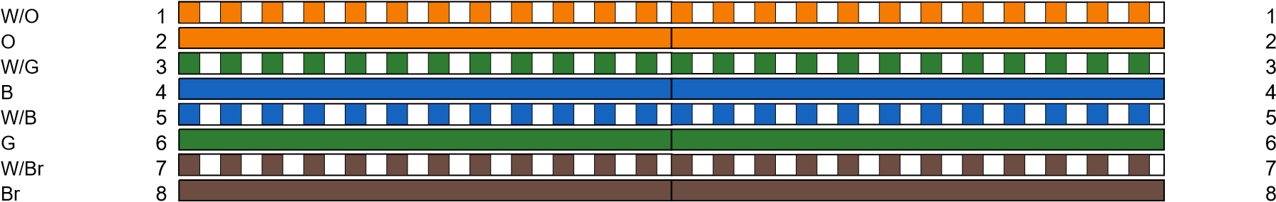
Fig 1: Straight-through cable (pin 1 to 1, 2 to 2 ...) Fig 2: Crossover cable (1 to 3, 2 to 6, 3 to 1, 6 to 2)
W/O
O
W/G B
W/B G
W/Br
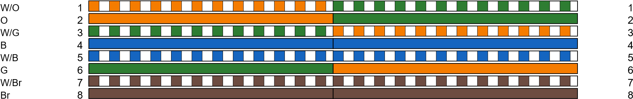
Br

Cable 1: Straight-through cable (T568B - T568B)

End A End B
W/G
G
W/O B
W/B O
W/Br
Br
Cable 2: Crossover cable (T568B - T568A)

LAN cable tester result
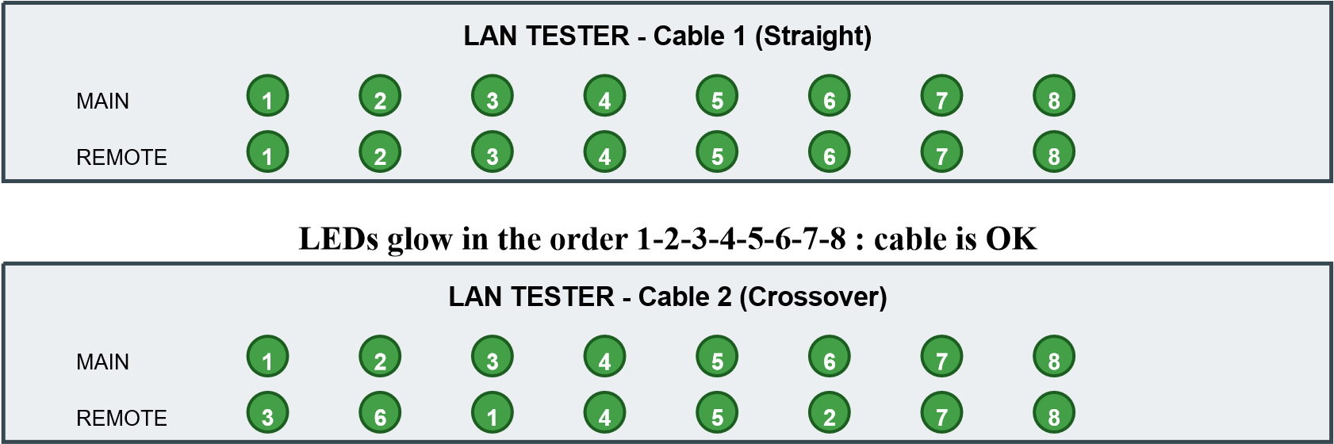
LEDs glow in the order 3-6-1-4-5-2-7-8 : crossover cable is OK
Cable | Main unit LED | Remote unit LED | Status
Straight-through | 1 2 3 4 5 6 7 8 | 1 2 3 4 5 6 7 8 | Working
Crossover | 1 2 3 4 5 6 7 8 | 3 6 1 4 5 2 7 8 | Working

RESULT:
Thus the different types of network cables were studied. A straight-through cable and a crossover cable were made using the crimping tool and both were tested successfully with the LAN tester.

